**How to create a directory**

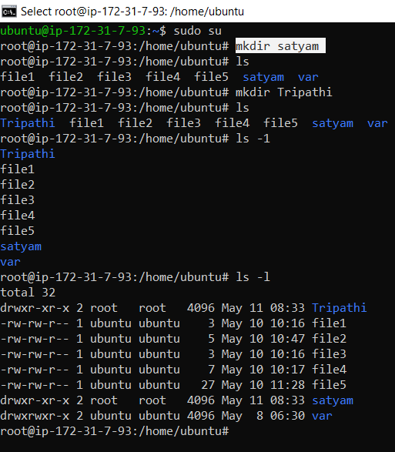

* Firstly we ceate a root directory

ubuntu@ip-172-31-7-93:~$ sudo su

root@ip-172-31-7-93:/home/ubuntu#

* Create a directory :-

**root@ip-172-31-7-93:/home/ubuntu#** mkdir satyam

**root@ip-172-31-7-93:/home/ubuntu#**mkdir Tripathi

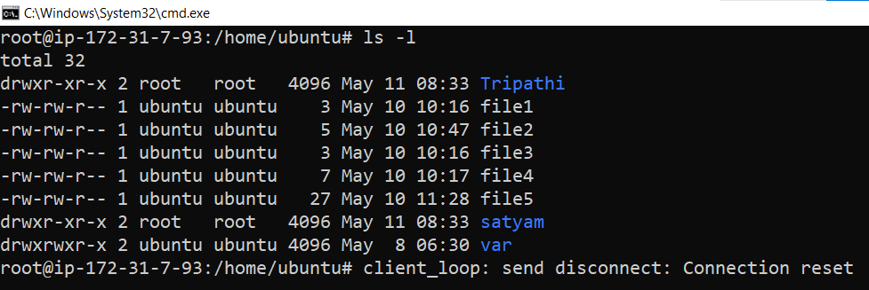

If we want to check our directory and file we put this command:

root@ip-172-31-7-93:/home/ubuntu**#** ls -l

drwxr-xr-x 2 root root 4096 May 11 08:33 Tripathi

if first word is **d** it means it shows this is a directory

-rw-rw-r-- 1 ubuntu ubuntu 3 May 10 10:16 file1

If first word is **–** it means it shows this is a file.

* **IF WE WANT TO CREATE A HIDDEN FILE :-**

We put this command to create a hidden file:-

touch .file6

* We always insert **(.)** before creating a hidden file.
* If we want to check our hidden file we put this command :-

ls –a

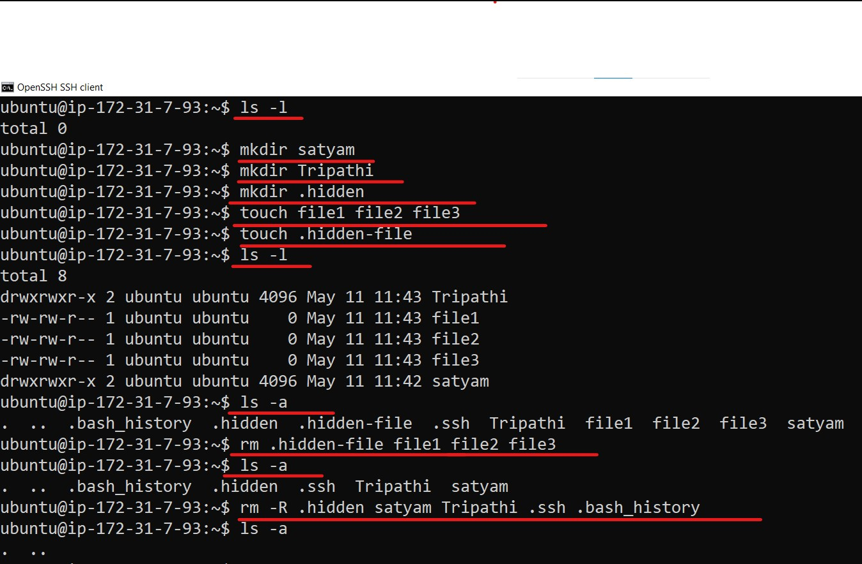

* **If we want to create a hidden directory we use this command in blue highlight.**

mkdir .(file-name) = mkdir.hidden

* **If we want to delete hidden file or without hidden file directory we use this command**

rm -R (FILE NAME) = rm –R .Hidden satyam Tripathi .ssh .base_history

* **If we want to see our hidden file we this command :-**

ls -a

**create Directory inside a directory**

* If we create a parent directory and inside a parent directory we create a new child directory, (which means to create a folder inside a folder.)

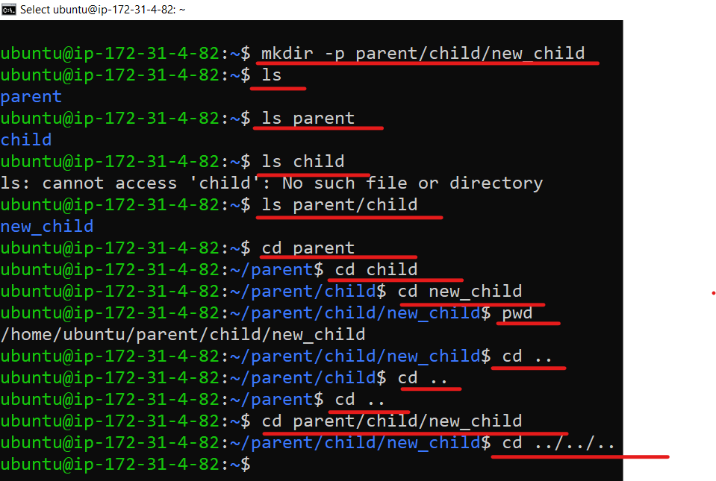

**ubuntu@ip-172-31-4-82:~$** **mkdir -p parent/child/new_child**

it means we create a first parent directory and in parent directory we create a child directory and in child directory we create a new child directory

**ubuntu@ip-172-31-4-82:~$** cd parent/child/new_child

This means we are going direct to the folder inside our child folder.

**ubuntu@ip-172-31-4-82:~/parent/child/new_child$** cd ../../..

it means if we want to come direct our root directory so we will give this command to come direct our root directory.

**Edit file data**

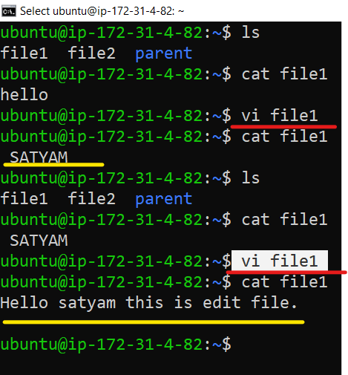

**If we want to edit our file data we use this command:**

Vi (file-name) = vi file1

**Copy file from one file to another file**

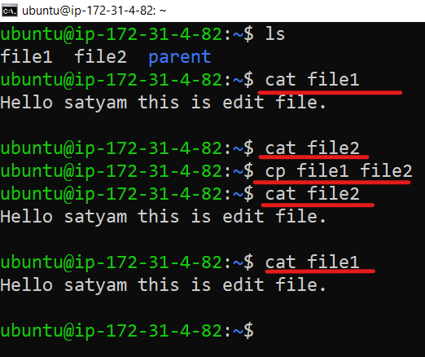

If we want to **copy** the file data to some other file then we do this command.

**ubuntu@ip-172-31-4-82:~$** cp file1 file2

In this command we copy file 1 data inside the file 2.

**Copy file from another directory**

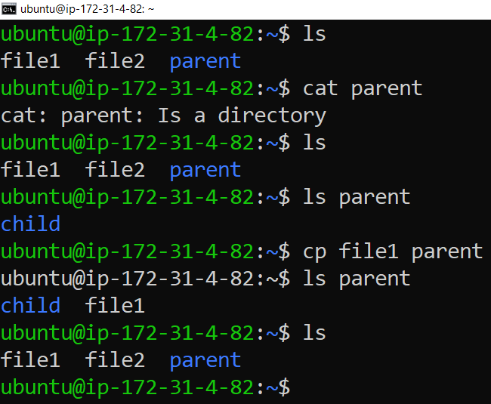

In this command, we copy file1 in parent directory, only copy a file not move a file.

**ubuntu@ip-172-31-4-82:~$** cp file1 parent

**Move file from another directory**

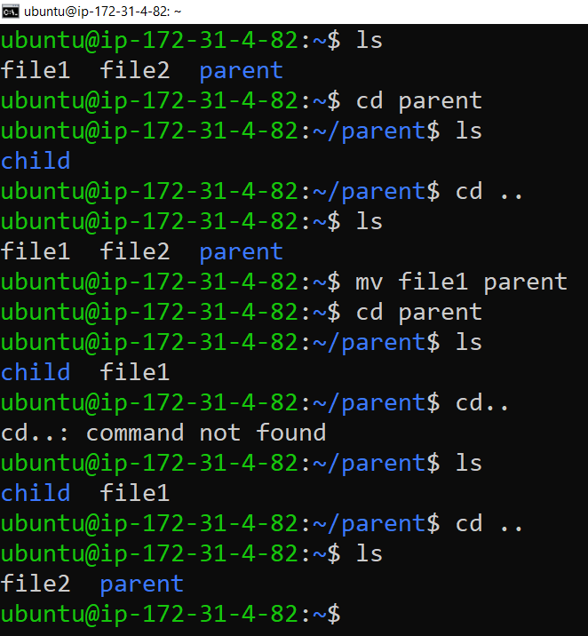

If we want to move a file in another directory we use **mv** command.

**ubuntu@ip-172-31-4-82:~$** mv file1 parent

**Rename directory**

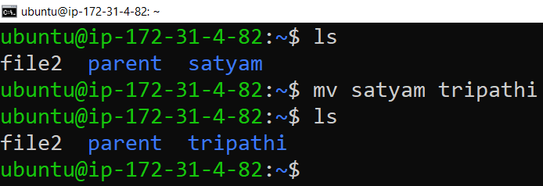

**ubuntu@ip-172-31-4-82:~$** mv satyam Tripathi

* if we want to rename our file we use **mv** command
* We use **mv** command to move a file or rename a file both.

**Hide a file or directory**

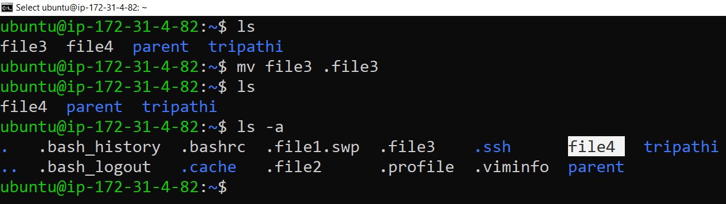

**If we want to hide our file and hide our directory we use this command**

**ubuntu@ip-172-31-4-82:~$** mv file3 **.file3**

We applied (.) Before file3 so that the file3 could be hidden.

**Delete file – Directory both**

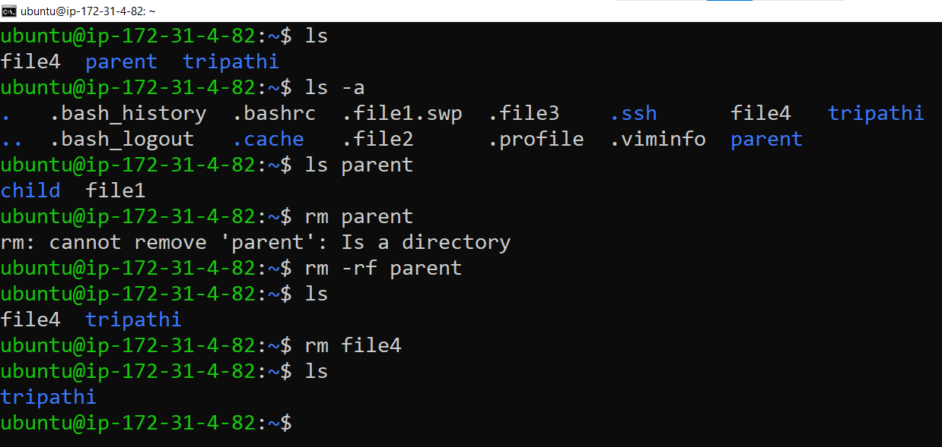

If we want to delete only **empty** file we use **rm** command only

**ubuntu@ip-172-31-4-82:~$ rm file4**

If we want to delete directory we use **rm –rf** command

**rm –rf** is a powerful command to delete our file and directory both.

**ubuntu@ip-172-31-4-82:~$** rm -rf parent